**Soumya Pandey**

**17th March, 2025- Progress Report**

Fixed Files and Folders

Revamped the home page for applicants:

* Moved the dynamic things above
* Moved the radar chart below

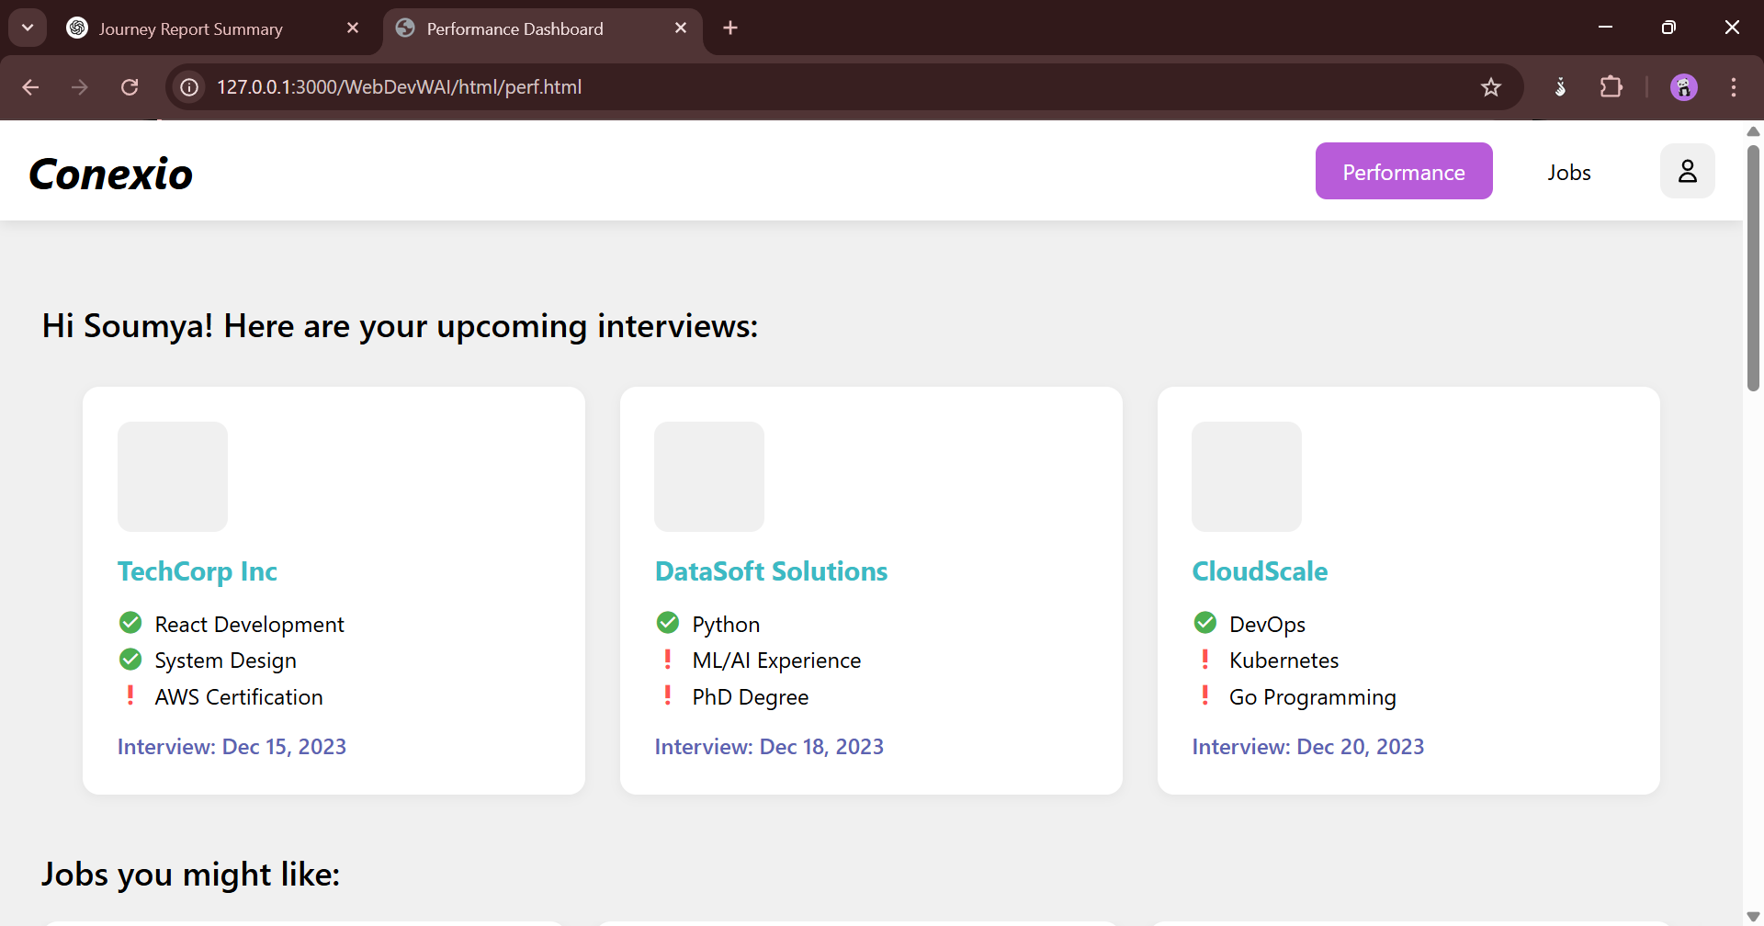

Redirected how I want the recruiter profile to look like:

* Changed from company’s review to how to manage applications (data will most likely be retrieved from manual input/their own database.

Create a new dummy DB for the updation of information on the cards:

* 5 attributes for each row

API specs required:

* Updating of cards for jobs (includes pop-up)
* Updating of cards for scout (includes pop-up)
* Watchlist for recruiters
* Watchlist for applicants
* Login
* Signup
* User information storage
* Password change
* Request data
* Save resume/hiring criteria
* Schedule for interview

Update the cards:

* Used FastAPI
* JS
* _babel which I removed then started working (React ended up not working in-line, will have to actively transform
* Looked at the response at the endpoint to format html for card updating and used debugging tactics.

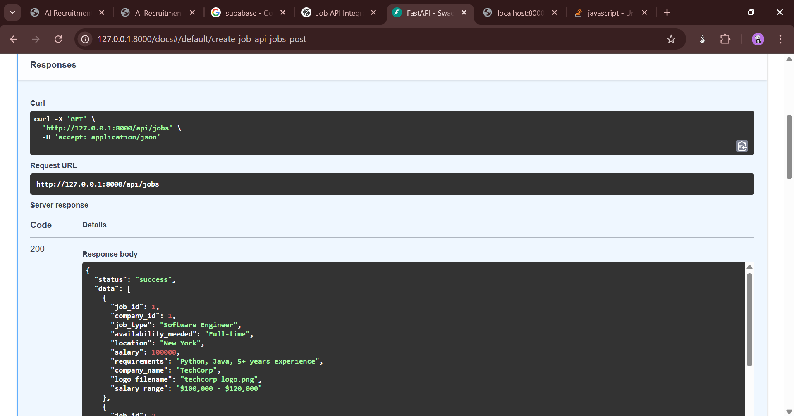

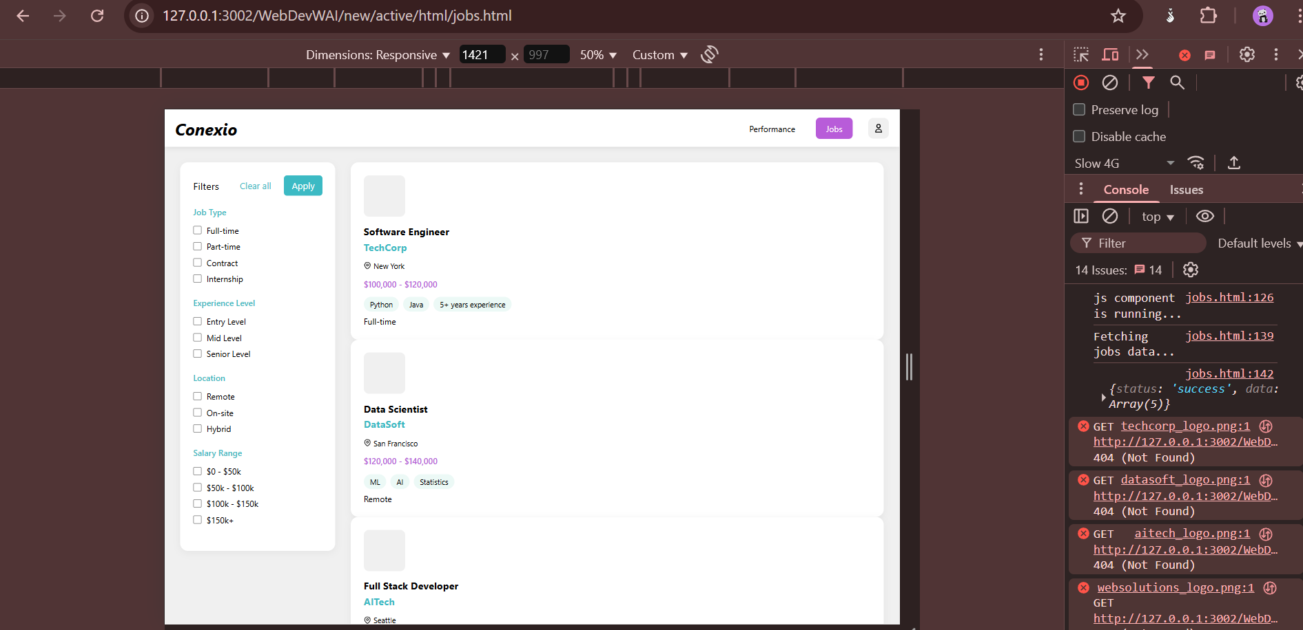

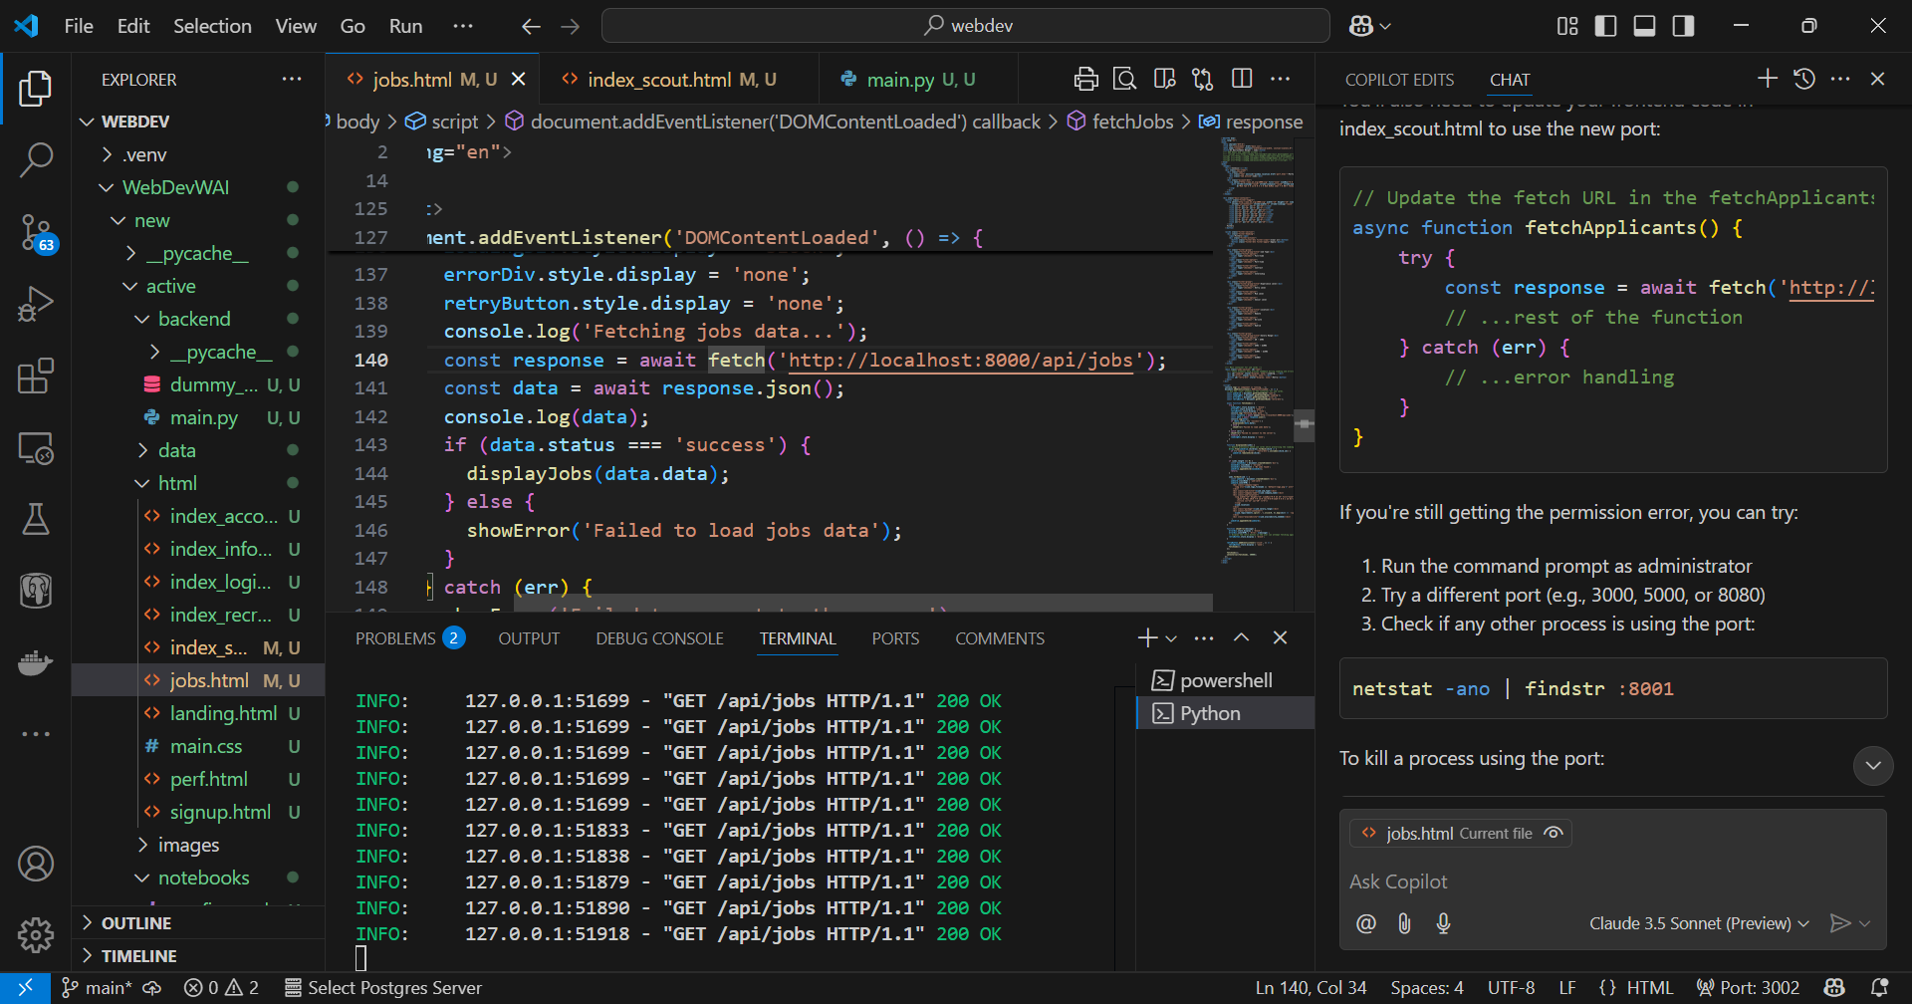

Same implemented on applicants

Watchlist

* Used FastAPI
* When clicked on add watchlist, updates the endpoint watchlist/add with the information of the card that was added that shows up on the home screen (not connected with the frontend yet but the backend has been done)

Login & Signup (authentication)

* Used supabase to enhance data storage and management
* PostgreSQL-based database for real-time updates.
* Easy authentication and API integration.
* File storage capabilities for resumes and hiring protocols.
* Secure storage of applicant and recruiter details.
* Authentication APIs for login and signup functionalities.

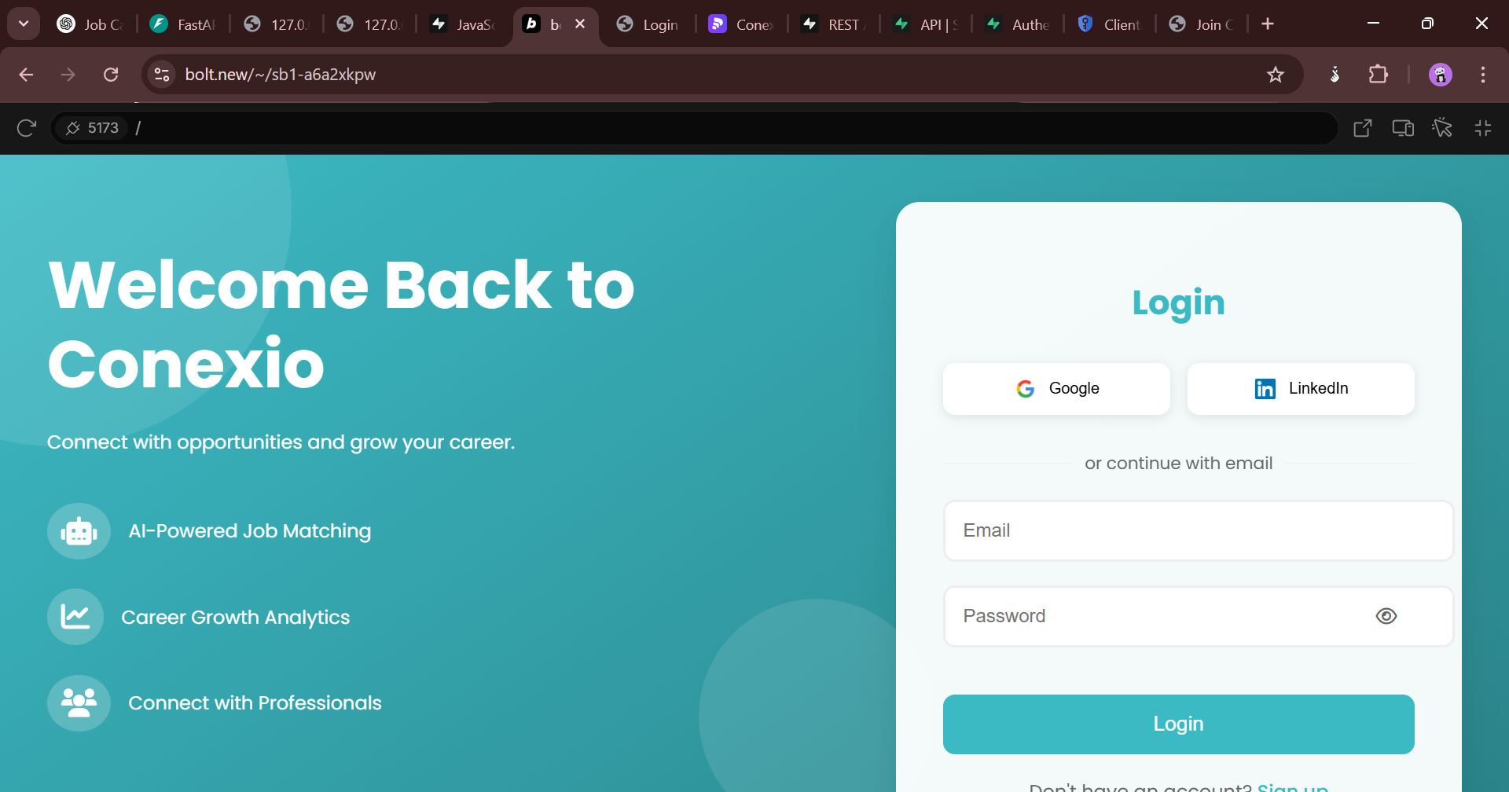

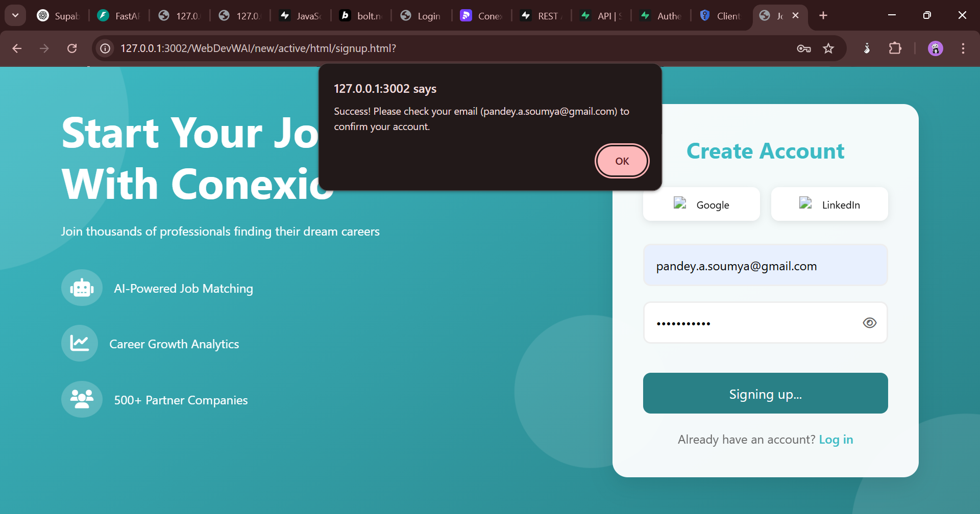

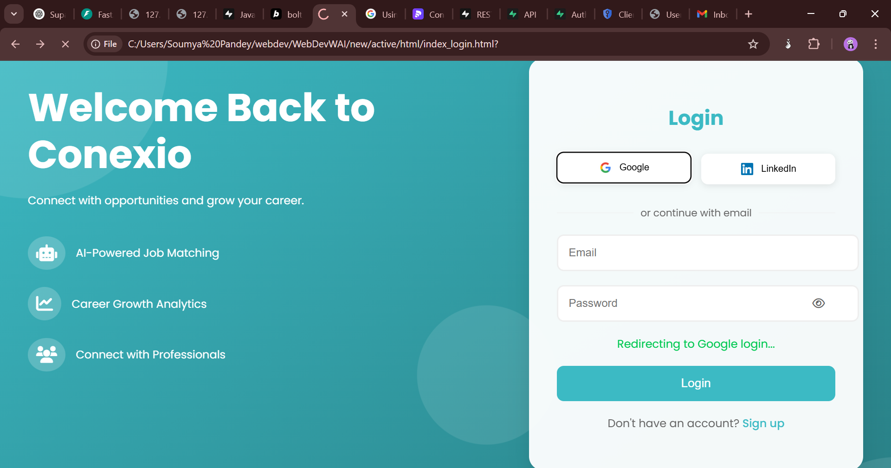

* Had to setup OAuth using Google Cloud in order to get google log in

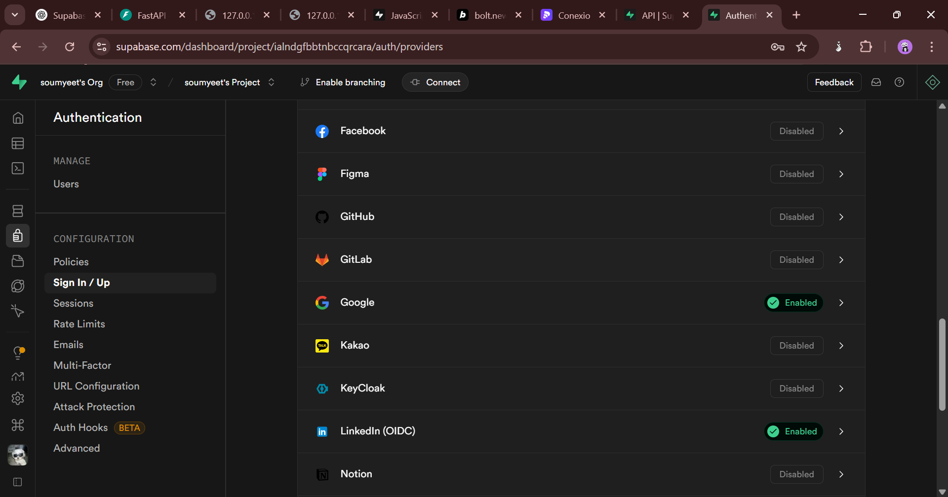

Future plans:

* User information (supabase)
* Collect files resume/hiring protocol

